# **GUI DESIGN – Simple Ball Game**

<THIS IS YOUR COVER PAGE – REFORMAT IT AS YOU LIKE - ENSURE THIS PAGE ALSO HAS YOUR NAMES>

YELLOW TEXT IN PURPLE = INSTRUCTIONS, REMOVE ENTIRELY ONCE FOLLOWED.

BLACK TEXT IN YELLOW = STUFF TO FILL IN, REPLACE WITH ANSWERS/INFO.

Contents

GUI DESIGN – Simple Ball Game 1

Document overview 3

Project GUI Requirements 3

Leading GUI requirements 3

UI Library Usage 3

Itemised GUI elements 3

Identify GUI & UI Events 3

UI Events 4

GUI Events 4

Design GUI 4

GUI Design Goals 4

Identify GUI structure 4

Initial GUI layout 4

Design GUI Functionality 5

<UI Element 1 Name> 5

<UI Element 2 Name> 5

<ETC> 5

Implement & Iterate GUI Design 5

Initial layout Implementation 5

Functionality Review 6

External Feedback 6

Planned Response to Review & Feedback 6

Iterated Implementation 6

Document overview

The purpose of this document is to show the planning, design, implementation of GUI scripting for a project, showing the full design loop of at least one area of the GUI. The document is broken up into phases to go through in order.

Project GUI Requirements

### Leading GUI requirements

* Timer
* Current Score & High Score
* Main Menu
* Main Menu buttons
* Pause Menu buttons
* ‘Ready’ & ‘Go’ text

### UI Library Usage

<Note what libraries will be used in script for the GUI, and how they are accessed. Look to the top of your GUI scripts…>

### Itemised GUI elements

**Screens & UI elements**

* **Player Screen** – Main Menu
  + **Start Button** – Simple button to start game
  + **Exit Button** – Simple button to quit game
* **Player Screen** – In-game
  + **Ready & Go** – ‘Ready’ and ‘Go text that appears when the game starts
  + **Timer** – Timer that runs down, appears 00:00
  + **Score** – Shows the number value of current player score and the current high score
  + **Game Over** – Appears when timer runs out

### Identify GUI & UI Events

#### UI Events

**Start Level**

* Display ‘Ready’
* After delay show ‘Go’ and then deactivate

**Goal**

* Score increases on goal
* Timer resets on goal
* High Score displays current highest score

#### GUI Events

* **Menu Buttons**
  + Start button starts the game
  + Exit button exits the game

Design GUI

### GUI Design Goals

* Minimal in-game UI
* Timer is obvious to the player
* Score & High Score differentiated

### Identify GUI structure

Most GUI changes will be driven by the player interacting with menu items or by simply playing the game, for example text updates on the canvas will mostly be changed by either starting the game or achieving a goal within the game.

### Initial GUI layout

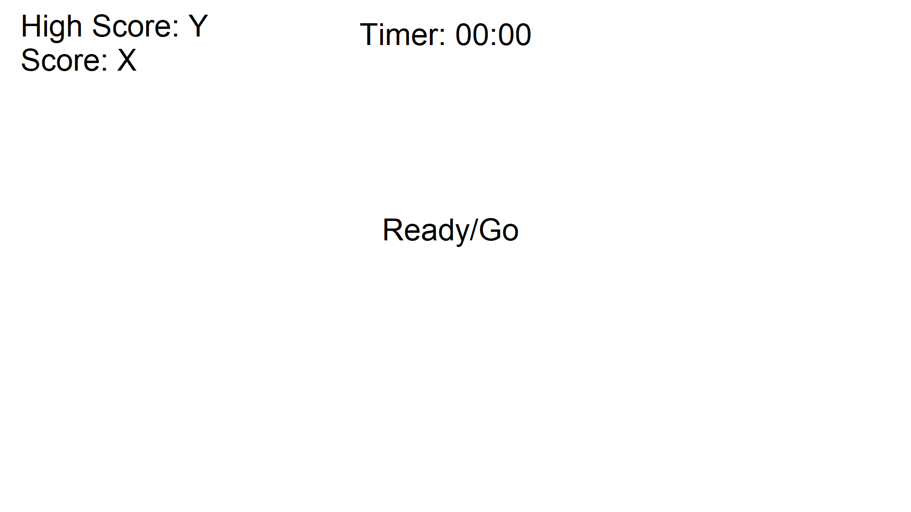

___________________________________________________________________________

* GUI elements are separated by their function
* Start Button path is larger because the most change will happen within it

### Design GUI Functionality

#### Timer

**Appearance:** PASTE IMAGE FROM MOCKUP

**Functionality:** A numeric timer that tells the player how long they have left to score a goal

* Appears in Seconds:Miliseconds format
* Counts down to 00:00
* Resets on Goal

#### Score & High Score

**Appearance:** PASTE IMAGE FROM MOCKUP

**Functionality:** Displays the current and highest score the player has achieved so far, increases upon goal

* Score is higher the more time that is left
* High Score is saved in to the menu and back in to the game level

#### Menu Buttons

**Functionality:** Get the player in and out of the game

* Start button to get the player in to the game
* Exit button to allow the player to quit the game

Implement & Iterate GUI Design

IN THIS FINAL SECTION OF THE DOCUMENT, YOU WILL DOCUMENT WHAT ACTUALLY HAPPENED WITH YOUR GUI ON IMPLEMENTATION, AND HOW YOU PLAN A RESPONSE TO BOTH A FUNCTIONALITY REVIEW (YOURS) AND EXTERNAL FEEDBACK. FINALLY, SHOW THE OUTCOME OF THE ITERATION. AGAIN, CHECK WITH YOUR TEACHER IF THEY WANT YOU TO COVER THE WHOLE GUI, OR JUST THE COMPONENT YOU SCRIPT.

### Initial layout Implementation

<Make a statement about the basic success or failure of the layout implementation of the GUI. >  
  
PASTE AN IMAGE OF THE INITIAL IMPLEMENTATION OF THE GUI – FOLLOW IT WITH BULLET POINTS IF THE IMAGES CANNOT HIGHLIGHT ISSUES PRESENT IN THE GUI SHOWN.

### Functionality Review

<Perform your own functionality review of your GUI – Do things work as intended? If not, how do they work? Make this clear in an **itemised** fashion >

### External Feedback

<Bullet-list the key feedback items you were given upon review of your implemented GUI. Keep the list manageable>

### Planned Response to Review & Feedback

Itemise the things you plan to do prior to attempting to implement an iteration

* <Planned Response & reasoning 1>
* <Planned Response & reasoning 2>
* <etc>

### Iterated Implementation

PASTE AN IMAGE OF THE ITERATED IMPLEMENTATION OF THE GUI – FOLLOW IT WITH BULLET POINTS TO OUTLINE WHAT ISSUES WERE AND WERE NOT ADDRESSED. IF YOU ITERATED MULTPLE ITEMS, MAKE THAT CLEAR WITH MULTIPLE IMAGES AND TEXTR.

* <Implementation Outcome 1>
* <Implementation Outcome 2>
* <etc>